|  |
| --- |
| Team NN: |
| MySystem Analysis and Design  MySystem Analysis and Design |
| CSIS 2200 Term Project |

|  |
| --- |
| Team Member Names Here |

MySystem Analysis and Design

1. Table of Contents

2 System Request Form 2

3 Business Case (Phase One) 2

3.1 MySystem Description 2

3.2 Rationale and Need for MySystem 2

3.3 Feasibility 2

3.4 Preliminary Investigation 2

4 System Planning (Phase One) 2

4.1 Project Deliverables 2

4.2 Project Scope 2

4.3 Project Plan and Resources 3

4.4 Project Budget 3

4.5 Project Risks 3

5 System Analysis (Phase Two) 3

5.1 System Requirements 3

5.2 Ongoing System Costs and Benefits 3

5.3 Data and Process Modeling 3

5.4 Object Modeling 4

5.5 System Development Approach 4

6 System Design (Phase Three) 4

6.1 User Interface Design 4

6.2 Reports 4

6.3 Security and Control 4

6.4 Data Design 4

7 System Architecture (Phase Four) 5

8 System Implementation (Phase Four) 5

# System Request

System Request – Gasoline Analyze Porject

|  |
| --- |
| **Project Sponsor(s):** Ömer Faruk GÜRBÜZ, Sinan Can SOYSAL, Abdullah TURHAN, Eray KAPLAN |
| **Business Need:** The purpose of this project is to exemine petroleum samples that taken by the client companies and return to them with a detailed analysis of the provided sample. We want to gain confidence and gain profits with the analyzes we have made. |
| **Business Requirements:** Our customers will be able to reach our website 24/7 via the internet. Each client company will be able to create their own accounts on the website, with these accounts they will be able to create a new petroleum analysis request, as well as examine the analyzes they have made before. The specific functionality that the system should have included the following:  -Allow to create a new petroleum analysis request,  -Allow to view analysis result,  -Allow to review old analyses,  -Present ıdeal gasoline values,  -Present comparison with past results,  -Consultancy service. |
| **Business Value:** First of all, we expect companies to request petroleum analysis by using our website, after that we will send them the oil analysis we have made for a certain fee. This will make up a large part of our revenue. We will also provide other small services such as: presenting the old analyses that we stored from the clients and presenting comparisions to past samples. We also expect to make a high profit from the consultancy service that we will offer to our customers.  Estimates of tangible value to the company are (yearly):   * $80.593.894 in revenues from the analyses that we made * $4.321.564 in revenues from the small services that we offer * $62.213.959 in revenues from the consultancy services |
| **Special Issues or Constraints:** Some companies do not need consultancy services becouse of the experts they have.  We need to develop innovative techniques to secure our leader posution in the market.  As the usage area of oil shrinks with each passing year, companies need less analysis. |

## My System Description

We will apply BPI strategy to improve our system.

**What is Business process improvement (BPI)?**

Creating new, re-designed processes to improve the workflows, and/or utilizing new technologies enabling new process structures.

Our company used to work slower than today. Advanced technology allows us to update our systems to meet today’s needs. Let’s take a look at our company’s old and new systems to better understand this situation:

**Process Stages In The Old System**

**Stage 1: Creating Petroleum Analysis Request**

In the past, when client companies wanted to have petroleum analysis done, they had to reach us via e-mail, after that our company would evaluate all these e-mails and send them a positive or negative response.

**Stage 2: Obtaining Oil Samples From Client Companies:**

Client companies take a sample of oil by carefully following the steps in the e-mail sent to them, then they had to deliver this sample to us.

**Stage 3: Delivering The Analyzes to Customers:**

The analysis of the sample examined by the technical team is sent to the client companies via e-mail. This e mail provides detailed information on the status of the oil, and at the same time, we offer consultancy services to our customers by using this e-mail. The process ends here for the customers do not want consulltancy service. Customers who want consultancy service, must send us an e-mail again.

All these processes took a long time on the old system, the rocesses could take weeks or even months to complete, also some glitches and problems could occur due to the slowness of the system.

**Process Stages In The New System**

**Stage 1: Creating Petroleum Analysis Request**

Now, customer companies can connect to our website with their own accounts and create an oil analysis request with a single click. The new system is designed to accept analysis requests from all member companies.

**Stage 2: Obtaining Oil Samples From Client Companies:**

Client companies take oil samples by following the steps on our website carefully, and then they have to deliver this samples to us.

**Stage 3: Delivering The Analyzes to Customers:**

The analysis examined in detail by the technical team, can be seen on our website with appropriate graphical designs and documents. The system will also offer our customers additional services such as consultancy service.

The new system saves time and minimizes the possibility of errors. All these processes take a few days at most. As can be seen from the explanations above, we want to make changes on the old system instead of compelely changing it. That’s why we prefer the BPI strategy.

## Inıtıatıon

**1-) Introduction:**

PLab is a company for oil suppliers to create petroleum analyze requests and see the results. The goal of this company is to provide these suppliers with the most accurate analysis and information about their petroleum. It offers customers to create a new petroleum analysis request and allows to view analysis result, it also offers a professional consultancy service.

**Membership:**

All customers need to apply for membership and pay the annual fees to the club. Analyzes can be made after membership, but our members must pay an additional fee for our consultancy service.

**System (How is it works?):**

Our customers who wants to have petroleum analysis done should contact us by e-mail, after that our company will evaluate all these e-mails and send them a positive or negative response. Client companies should take a sample of oil by carefully following the steps in the e-mail sent to them, then they have to deliver this sample to us. As soon as the sample reaches us, it is examined by experts. The analysis of the sample examined by the technical team is sent to the client companies by e-mail which provides detailed information on the status of the oil, and at the same time we offer consultancy services to our customers by using this e-mail. Customers who want consultancy service, must send us an e-mail again.

**Problems and proposed solutions:**

**Problems:**

As it can be understood, the current system consist of long processes. Messagging situations with all these customers prolongs the process. Also since we do not have a web page of our own, we cannot control the security of our system which creates many drawbacks to the current system.

**1) The Slowness of the System**

The system is running very slowly as many independent actions have to be done manually. Messaging and fedback via e-mail prolongs the process.

**2) System Security**

Since we usually communicate with our customers using e-mail, we are generally vulnerable to unwanted situations such as hacking

**3) Unnecessary E-mails**

Unfotunately, in the current system, we receive a lot of unnecessary e-mails not only from our customers but also from different people or organizations.

**4) Less Services**

Since communication with customers is already difficult, we cannot offer them some of our useful services.

**Proposed Solutions:**

**1) New System**

By establishing our own website, we must build a faster system where we can communicate directly with our customers. This will also allow us to maintain the security of the system.

**2) System Membership**

We can eliminate unnecessary e-mails by only responding to analysis requests of our customers who are members of the system.

**3) Service offerings**

We can offer many different services to our customers with a single click on our own website.

**What is our goal?**

The reason we make all these changes is to increase system security, speed it up and increase customer satisfaction. We want to be the best known company in oil analysis.

## Project Plannıng Phase

**Project Planning:**

While preparing our new system, we weill apply the SDLC methodology to save time and money.

**What is SDLC?**

The system development life cycle (SDLC) is the process of determining how an informaiton system (IS) can support business needs, designing the system, building it, and delivering it to users.

**1- Planning Stage**

The planning phase in our system will proceed as follows:

Firstly, the project manager will set specific goals for the system, then he/she should form teams and make assignments to achieve all these goals. At this stage every detail important and critical for the functioning of the System must be defined.

A board of directors will be created in our current system. This board will draw up a roadmap by taking advantage of our old company experiance. Since we want to be the best company in oil analysis, we have to minimize the errors, therefore we must anticipate and prevent many errors that may occur in the future. We should use technological advantage and we must constantly make long-lasting plans and make decisions that minimize costs and time loss. The planning phase covers a period of a whole year.

**2- Analysis Stage**

Oil experts selected by the management will search for up-to-date data, at the same time, they will constantly examine the oil data uploaded to our system. They will also inform the management by preparing a detailed report that meets the needs and targets of our sytem from the data they obtain. The management will use this report when making a future decision about the company. We want our system to work faster and stable, so our experts shoud prepare their reports carefully. These experts should also identify improvement opportunities, and develop new concepts for the new system.

**3- Design**

Design is one of the most important factors for us. We have to be careful especially when designing the user interface. We will create a confusing yet elegant interface in the design of our website. Our customers shouldn’t get lost in the interface and shoud be able to find everything they’re looking for here. For all this to happen we must carefully select our web designers.

**4- Implementation**

In this phase, everything will be under the control of our developers here. Customers, officials administrators, developpers, etc. Users must have separate login permissions to the system. Since the proper functioning and safety of the system is very important to us, we must have the system audited by experts constantly. Also petroleum experts should do their analysis as carefully as before, then, these analyzes should be carefully loaded into the system and delivered to the right customer.

In the old system, it could take weeks for us to receive oil analysis requests from our customers and send them the analysis results. In the new system, the estimated period will be a maximum of 1 week.

**5. Maintenance and support phase:**

This phase comes right after the implementation phase. It is an important stage in terms of continuous development and support of the system even while it is running. The system is kept up-to-date by eliminating the deficiencies seen in the working system and making updates.

## Data Design

1. Customer can register to portal
2. Customer can pay for analysis
3. Customer can send samples for analysis
4. Customer can send feedback
5. Customer can view analysis results
6. Laboratory can verify/deny register request
7. Laboratory can receive payment
8. Laboratory can receive samples
9. Laboratory can review feedback
10. Laboratory can analyze samples
11. Laboratory can update analysis results

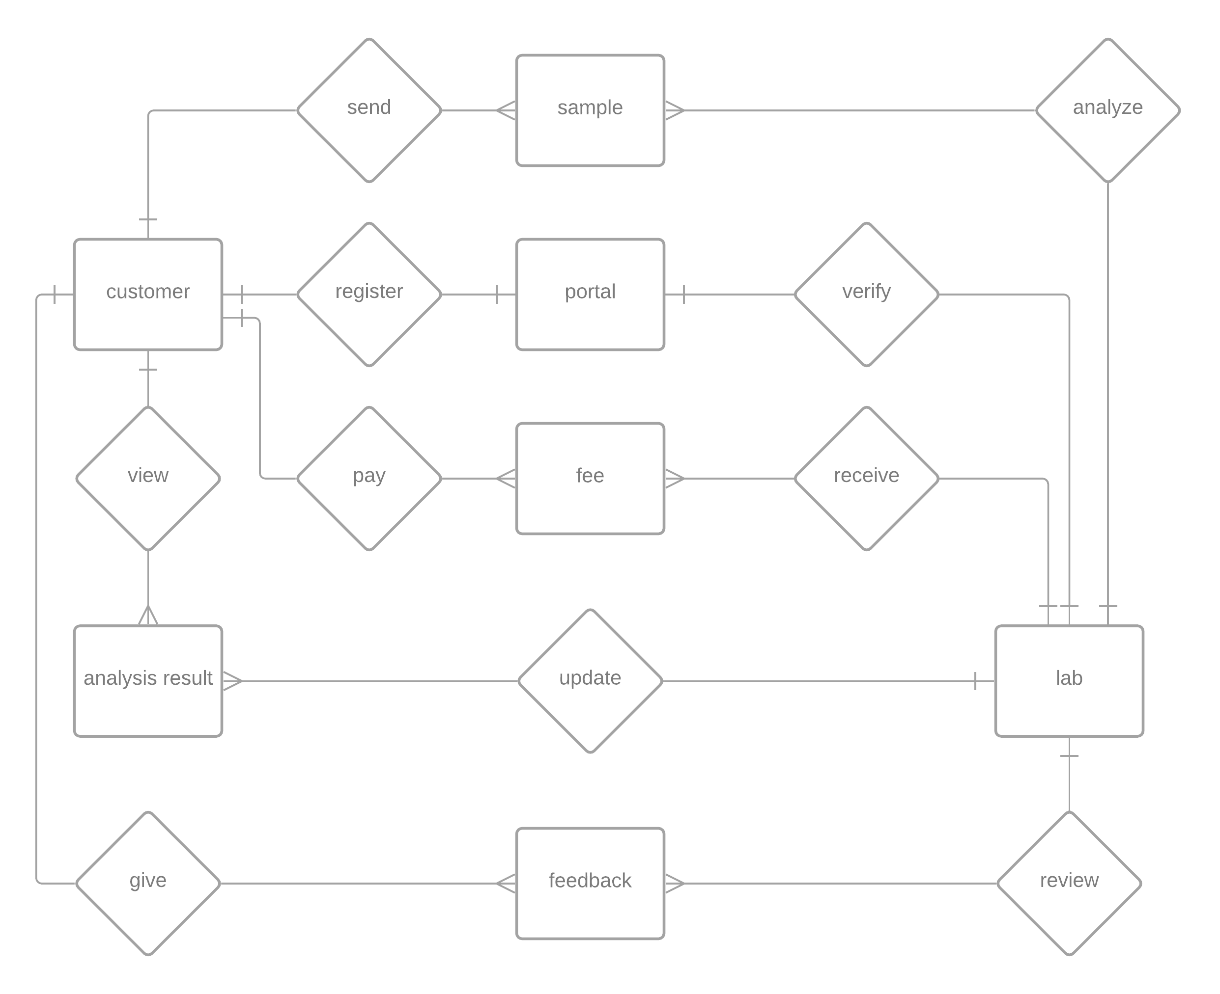

*figure 6.4.1: ERD Diagram*

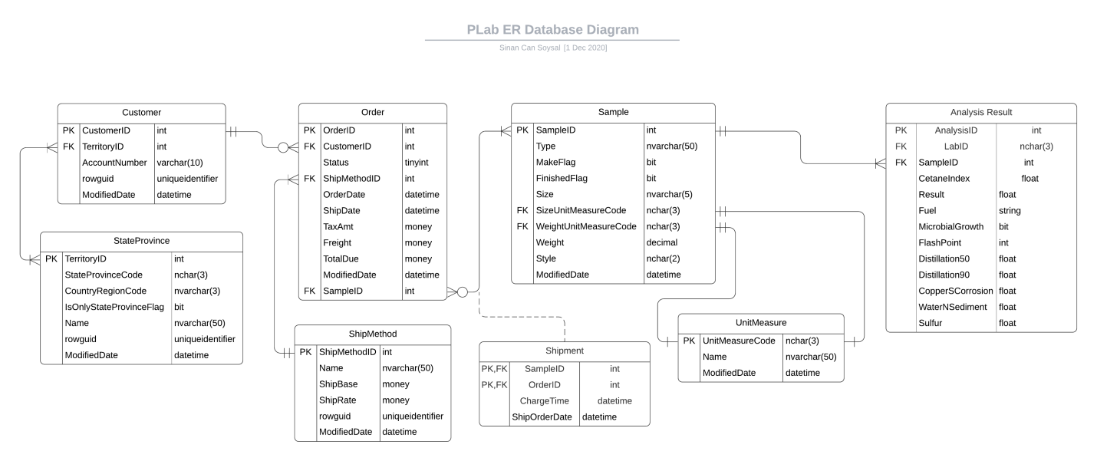

*figure 6.4.2: Database Design Model*

# System Architecture

## Architecture Design

This portal will provide a bridge between customer and PLab Laboratories. The client must be able to see the results of a sent sample easily. Client logs into the PLab Portal in order to reach analysis results. One client can have multiple samples sent at the same time and the system must be able to handle all of them without malfunctioning. Laboratories across the country can update analyzed sample results throughout this portal. After analysis result uploaded, client can view it’s analysis reports visually.

There are 3 main packages of this comprised system:

1. User Interface
2. Data Storage
3. Business Services

User interface will provide user interaction to the system. User interface must be able to support login, create sample requests, generate graphical representation of an analysis result, view results and send feedback to the system.

Data storage must provide reliable and secure data storage for the system. Client details, sample details, shipment details, fees, analysis results must be safely stored in the data storage. Business management and clients can reach needed data at any time from anywhere.

Business services contains the details of billing system, reading/updating data from database and managing client-business interactions.

Proposed system shall integrate with existing legacy system.

Our application works with large amounts of data provided by the labs around the country. In this situation, data will be accessed frequently by laboratories and clients. In order to accomplish this we must architect our application as a data-oriented system. The main reason of this architecture is to achieve integrality of data.

A centralized data repository will store all of the analysis results and it will be accessed through client side and business side API s. API’s will create queries according to the user’s needs.

**Advantages of this architecture:**

1. Data integrity
2. Backup and restore features ( this is the most important feature because our clients’ must reach their data whenever they want and wherever they want)
3. Decreases overflow of data between software components

**Disadvantages:**

1. The system is open to malfunction
2. Malfunctions will highly affect the clients

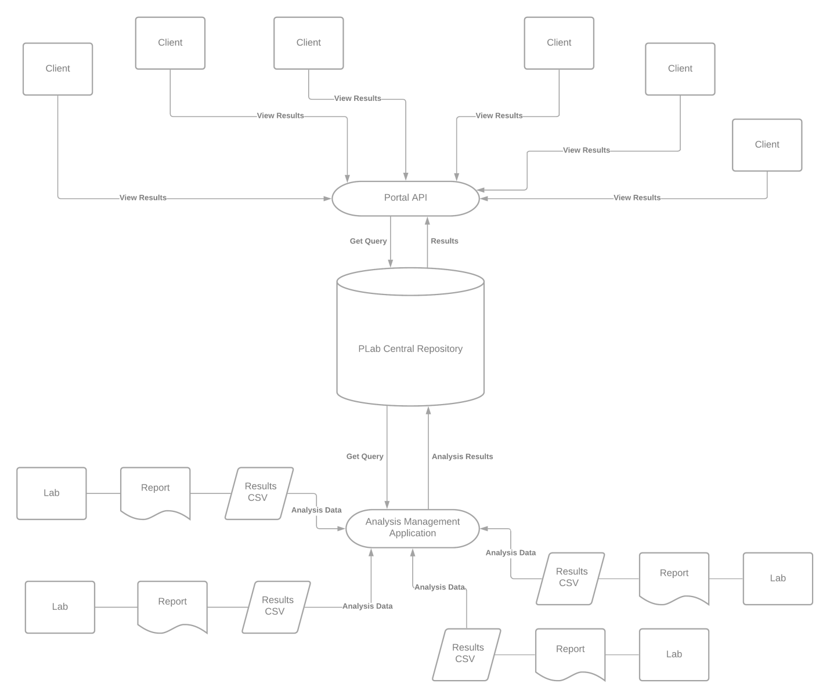

*figure 7.1.1: Architecture Design*

The system shall support up to 2000 simultaneous connections to central repository at any given time.

The system shall provide users to view older results with no more than 5 second latency.

The system must finish its transactions within 2 minutes.

According to these and previously evaluated requirements document:

The selected architecture design must support the sizing and timing requirements through client-server architecture. The client part is implemented on PCs and ensured to use minimal disk and memory.

**The architecture supports quality requirements:**

1. Linux, Windows, Mac OS support
2. User interface shall be designed for easy use
3. System must be available 24/7

## Software and Hardware Specification

To successfully accomplish the requirements of the project, some modern technologies have been suggested for the better service and security by having an online portal an an online sample registration system. This document contains all the software and hardware technology that has been proposed for the new system.

**Software Specifications:**

Application will be controlled by:

1. Python & ZingChart as front-end solution
2. PostgreSQL as database solution
3. GoLang as backend solution

Python is a rich programming language in terms of it’s data visualization libraries. User interface must be beautiful and simple at the same; ZingChart comes into play for the visuals of the portal. ZingChart is a free and powerful python library specifically developed for data visualization.

PostgreSQL is a free and open-source relational database which will get it’s job done in a fast and secure way.

GoLang is a programming language designed by Google. Go routines are GoLang’s most important future so far which allows concurrency in web based solutions.

**Hardware Specifications:**

We will support this project’s hardware by installing our own server rather than a subscription for cloud services.

**Dell PowerEdge R710 6B LFF Server**

R710 will be the main server for “PLab Analysis Laboratories” system. R710 will help us to operate efficiently and lower TCO with enhanced virtualization capabilities, improved energy efficiency, and innovative system management tools. It provides railings for easy installation and removing operations. Also it supports RAID operation with 12TB of storage. It’s CPU donated with 12-core Xeon processor and 12Mb of cache. The main unit manufactured by Dell, and the case is designed to allow accessing to hard disk drives easily. The server has got 2 power supply units for continuous working even if one of the power supply mulfunctions.

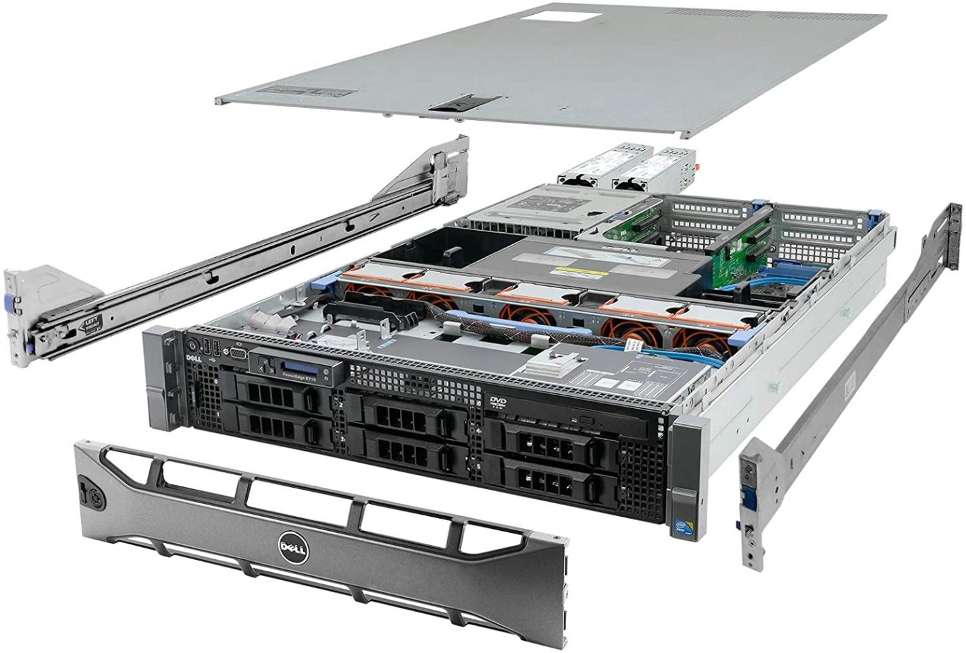

Figure 7.2.1: Dell PowerEdge R710 6B LFF Server

|  |  |
| --- | --- |
| Hardware: | Price: |
| System: Dell PowerEdge R710 6B LFF Server   * **Processors:** 2x 2.83GHz X5670 12-Cores Total * **Memory:** 144GB RAM * **Hard Drives:** 6x 2TB 3.5" HDD * **RAID:** H700 w/ 512MB * **Optical Drive:** DVD-ROM * **Power Supplies:** 2x PSU * **Bezel:** Yes * **Rails:** Yes * **Operating System:** None | $ 729.99 |

**Additional Hardware for Network:**

Every laboratory has its own central computer so, we won’t be buying new computing hardware to the existing laboratories instead we will deploy a new software to existing computers. A communication link will be needed between all the laboratories and the PLab’s central repository. The link will be provided by our existing ISP and the whole communication structure will be called as ‘Chiral Network’.

# System Implementation

Provide implementation plan, add to project plan.

Include coding approaches.

Update budget as necessary.

13-USER INTERFACE OF THE SYSTEM

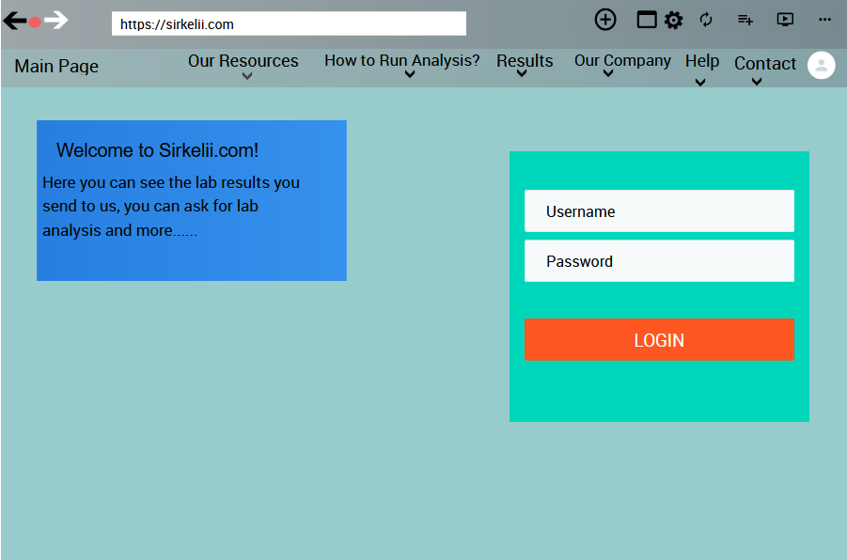

Register

In the photo above you see our system “Sirkelii.com’s” main page it may seem a bit dull but it is the most useful one we have ever used.In this format our users/costumers had the most efficiency in using it and our percentage of usage raised drastically.Without further ado let’s begin of explanation of the page:

1. Main Page Button:While in other pages that button leads you to the main page without dealing with back or forward buttons.
2. Our Resources:When someone touched to this it will show 2 sub-page buttons;”Our Psychical Sources and Our Online Sources”.
3. How to Run Analysis?:It redirects you to explanation page of how we run your analysis in the most clear way.
4. Results:This button redirects you to the our results page.In there you can see if your result has come out or not, can check old results, can see when your result is going to come.
5. Our Company:This button will show you two sections; “Our Company’s History” and “Our Purpose”.
6. Help:This button redirects to help page that has the all information about most common needs and problems and their solution,the questions about our company and about our way of doing the analysis.
7. Contact:This button redirects to our connection page that has the all info on how can you get contact with us.
8. Welcome to Sirkelii.com:It has the basic info about us.
9. Login/Register:It let’s you to login our page and if you are not registered it redirects you to registration page.

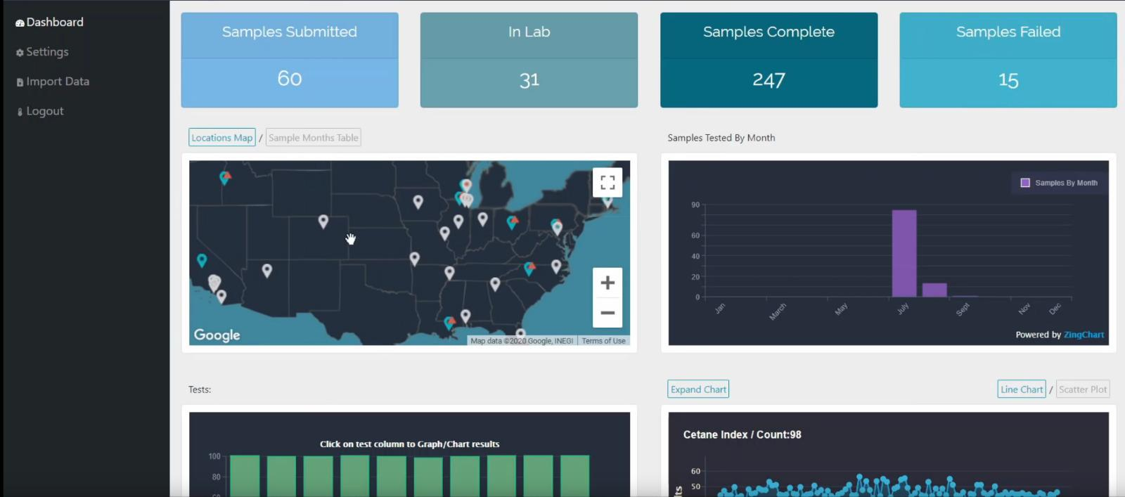

This page above is our “Results” page(only above part).This page includes:

1. Samples Submitted:It shows the submitted samples in a month.
2. In lab: Shows the current tests that are running in our labs.
3. Samples Complete:It shows the completed samples in total.
4. Samples Failed:It shows the failed samples in total.
5. Maps & Graphs:They show our usage and success in the areas and other companies.
6. Help Block:It has the data of the sections of Dashboard, settings, import data and logout:
7. Structure Chart

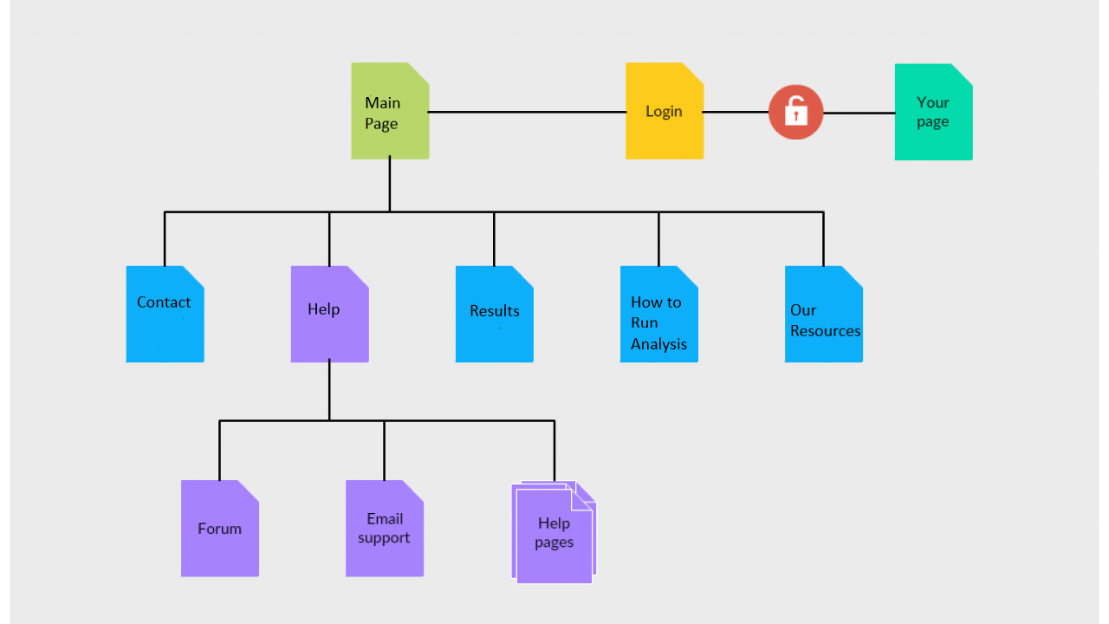

The Structure Chart:It has the basic info of our main page’s sections which are;”Main Page, Our Resources, How to Run Analysis,Results,Help,Contact”.

15)System Implementation:

To implement the system I need to understand it’s requirements, plan it’s process,develop and document it’s steps and needs,do a training of it,do the implement,test te system and due to results try to decide how to adjust and improve of it.

1)To fully know it’s requirements I must carefully search and learn it then I must document the requirements and make things crystal clear.

2)I should plan the process and see if these tasks are happens correctly or not:

-Evaluating and assessing unsuitability triggers like customer complaints, audit findings, process parameter,etc

- Identifying legitimate unsuitability related issues

- Capturing and entering issues into the corrective action process

- Investigating and getting to the root cause of an issue

- Determining and implementing solutions

- Reviewing, checking, and verifying the effectiveness of a problem resolution

· Using risk management protocols to ensure major nonconformances are top priority

· Establishing personnel responsibilities at various stages of the corrective action process

1. I should develop and document this process and see if it’s well developed and useful or not.After developing it I should make sure if the system works properly with conducting a test
2. After the test the real implementation begins.
3. After the implementation the real test of the system begins. In this test we check the system to see if it’s ready to use or not, can it do it’s objectives like it supposed to do,does it need any changes?According to the test results we decide to either it need any improvement and adjustment or not.
4. As in the final step we make adjustments to the system and make some proper improvements to it and make the system fully developed,functional and usable.

If we don’t do these steps with this order and form, the system implementation will be very risky with high chance of failure.So, to prevent this I must not be hasty and make this in the way it should be or our time,resources and our system will go to waste.

16)How to Support the System?

First of all our website “Sirkelii.com”and it’s system has one of the best software systems and designs in the entire world.We are proud of that because our system has won “The Best Website of the Year” from the Awwwards in the last 3 years.

If anyone asks how our system has become like this it was a difficult thing to achieve it.....Our system had a lot of bugs and glitches for months when we first opened it in 2014 but then after we found our current I.T. guys and asked them for their help and they started to work on our system then they are started to shine.The new duo figured out some of the biggest bugs in the system and thanks to them we have see our mistake and changed them with our old “I.T.” guys.

Since then our website has updating it’s software monthly.

Then after these bugs disappeared we had another troubles;website speed,HTML errors,.....

Our speed was quite low after all these bugfixes because it couldn’t handled the process of the new updates.So,we started to check it every week instead of month and our geniuses fixed the speed trouble shortly after founding it.They have made some improvements in the system’s very own core and thus our speed has become quite fast.

We had HTML troubles due to some code problems but ey were easy fix to our masterminds.

After our bugs so started to decrease intensely, we started to look for the other websites to improve ourselves and the results was quite impressive we saw a lot of improvements.

We have developed a lot of new content we have to our new sections:”Our Resources, How to Run Analysis, Results,Our Company”.

Secondly our biggest chance was our website had a lot of costumers/users that searched us in the search engines but they had troubles due to our first name...After changing it to “Sirkelii.com” and a successful “Search Engine Optimization” our website was quite easy to find and it made our website one of the biggest reached websites for that year(2015).

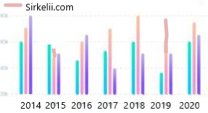

In 2017 our high numbered users/costumers had some trouble with the system’s design due to it was a little out of numbers so we have updated and improved our core design to this current version(below) and people started to use it more efficiently and easily.



Finally after all the needs of our costumers/users we have made a few changes in the design and links to our system with the costumers/user’s suggestions, thanks to our brilliant I.T. duo and great costumers/users we have one of the greatest systems and we still improve it day by day thanks to these steps we learned.